هوالعالم
راهنمای نصب گرافیک RTX-3090 برای استفاده از GPU
جدول سازگاری برای 3090
 |  |  |  | tensorflow | cuDNN | CUDA
 |  |  |  |  | v8 | v11

- نصب آناکاندا با دسترسی ادمین
- ایجاد یک محیط مجازی با پایتون 3.8 یا بالاتر
  - conda create -n tf2 python=3.8
- فعال سازی محیط مجازی
  - activate tf2 or conda activate tf2
- نصب تنسورفلو
  - pip3 install tf-nightly-gpu1
  - برخی منابع
- pip install tensorflow (With GPU Support) //Install TensorFlow GPU command, pip install --upgrade tensorflow-gpu

- دانلود CUDA v11
  - https://developer.nvidia.com/cuda-downloads
  - یا https://developer.nvidia.com/cuda-toolkit-archive
- دانلود Microsoft Visual Studio version for C++
  - https://visualstudio.microsoft.com/downloads/
  - install the C++ components
  - "Desktop development with C++" را انتخاب کنید
  - 6 آیتم اول را انتخاب کنید
  - از راهنمای زیر کمک بگیرید

Visual Studio Community Edition 2019
The core of NVIDIA TensorRT is a C++ library that facilitates high-performance inference on NVIDIA graphics processing units. This is why we must install the necessary C++ libraries using Visual Studio.
- Double click the installer to launch.
- Click continue and it will download a few files
- Scroll and select desktop environment with C++

- نصب کننده CUDA v11 را اجرا کنید.
  - در مسیر زیر نصب می شود
  - "C:\Program Files\NVIDIA GPU Computing Toolkit\CUDA\v11.1"
- از مسیر زیر cuDNN را دانلود کنید
  - https://developer.nvidia.com/rdp/cudnn-download
  - باید در سایت لاگین کنید.
  - در دانلودها سه فولدر را مشاهده می کنید ("bin", "include", "lib")
  - این فایل ها را در دایرکتوری CUDA v11 کپی کنید
- تعریف متغیرهای ویندوزی با توجه به مراحل زیر :
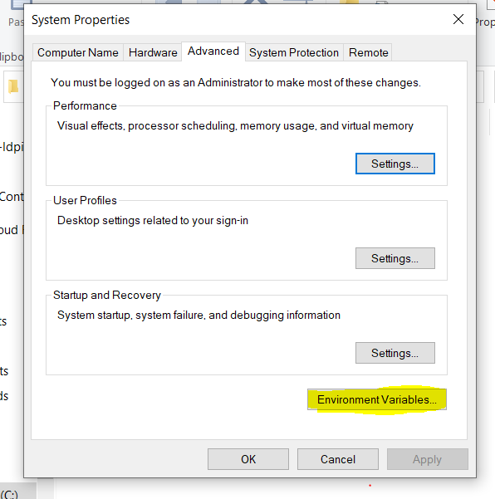
--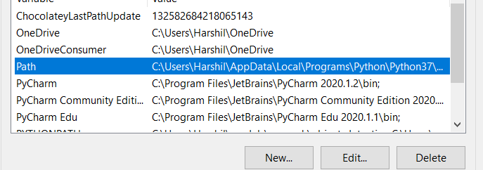
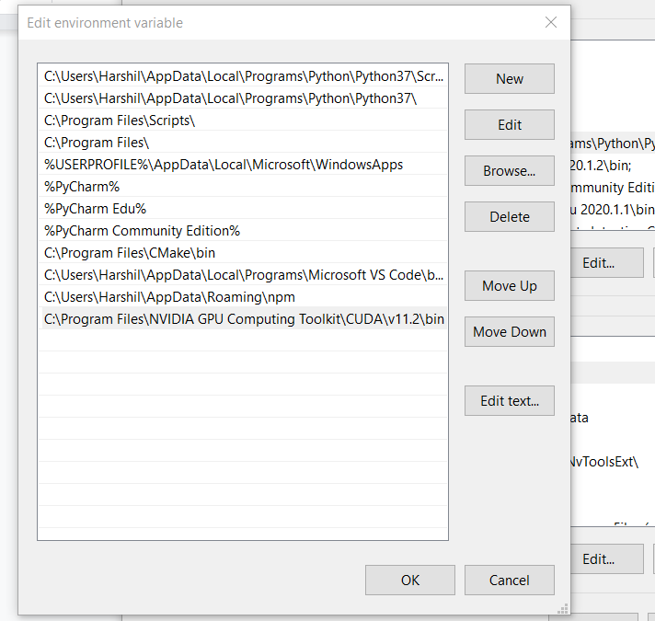

Now, let's add those directories to the system path. In windows, open start and search for "This PC". Rightclick and select "Properties" to open a Window called "System". On the left side at the bottom, select "Advanced system settings". Click "Environment Variables..." at the bottom. Here, in the lower half, in "System variables", find and open "Path". Here, click "New" to add a new directory to the system path. Do this every time for each of the following directories (as mentioned earlier, the version number may be different for you). Some of the directories may be already listed there, so feel free to skip them (there is no negative effect from double entries though, so don't worry too much):
C:\Program Files\NVIDIA GPU Computing Toolkit\CUDA\v11.1\bin
C:\Program Files\NVIDIA GPU Computing Toolkit\CUDA\v11.1\libnvvp
C:\Program Files\NVIDIA GPU Computing Toolkit\CUDA\v11.1\extras\CUPTI\lib64
C:\Program Files\NVIDIA GPU Computing Toolkit\CUDA\v11.1\include
- سیستم را ری استارت کنید
- برنامه خودرا اجرا کنید
  - برای تست
- # importing the tensorflow package
- import tensorflow as tf
- tf.test.is_built_with_cuda()
- tf.test.is_gpu_available(cuda_only=False, min_cuda_compute_capability=None)

- اگر جی پی یو نمایش داده نشد. نکته زیر را بررسی کنید
Your GPU may not show up. Take a close look at the output of the console (for me, it was the anaconda prompt with which I started up my jupyter notebook). There, you should see logs like tensorflow/stream_executor/platform/default/dso_loader.cc:49] Successfully opened dynamic library cudart64_110.dll or a similar log stating that a certain DLL could not be loaded! In my case, everything loaded except the DLL "cusolver64_10.dll". So, I went to the CUDA v11 directory (C:\Program Files\NVIDIA GPU Computing Toolkit\CUDA\v11.1), opened the "bin" folder (the DLLs are in there) to check if that DLL was there. Nope, it was not. Instead, there was "cusolver64_11.dll". So what I did was just copy that DLL and renamed the copy to "cusolver64_10.dll". Yeah, sounds dumb, but after that, everything worked.

یک کد ساده برای تست:
https://github.com/aladdinpersson/Machine-Learning-Collection/blob/master/ML/Pytorch/Basics/pytorch_simple_CNN.py

